**Lab 1: Histogram**

Objective: Introduction to image processing in Matlab, and image enhancement.

Instructions:

* Download “Matlab Tutorial_v1.pdf” from the course website
* Download “lab1.docx” (this document) from the course website.
* Complete each part and paste the resulting images into this lab1.docx document.
* **Print and bring your lab sheet** to the lab in your registered lab session.

Lab interview:

* Show your student card to a TA.
* Show your work to the TA who will check off that you have completed the exercise.
* Be prepared to answer any questions from the TA about what you did.
* Upon completion, ask the TA to put the total mark and their signature on this lab sheet.
* The TA will collect your **signed/marked** lab sheet **in the lab**. Make sure of your name and student number.

**Student name: Total mark:** / 3

**Student number: TA signature:**

**Part I [1 mark]:**  / 1

Download a **medical** image of your choice from the internet that is bigger than (100 x 100) and less than (1000 x 1000) pixels and save it. Copy and paste your image here.

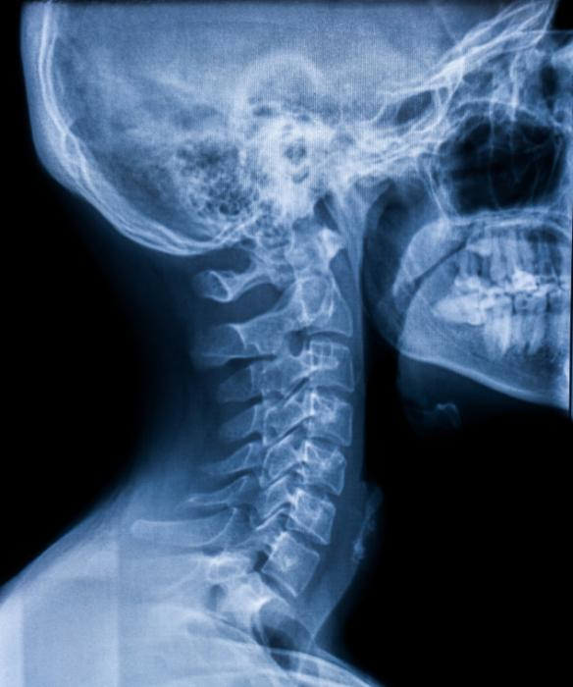

* In the lab, show your image to a TA using Windows Picture Viewer. (Double-click the image file downloaded.)

**Part II [1 mark]:**  / 1

Open the Matlab software. Set the working directory where your image is stored. Execute the commands from #1 to #4 given in “Matlab Tutorial_v1.pdf” available in the course Brightspace.

* How many pixels by pixels does your image have? 584 x 700 .
* What are the data sizes of your image?

Original image file: 39,777 bytes,

Image read by *imread*: 1226400 bytes,

Image converted by *rgb2gray*: 408800 bytes, (36,580?)

What is the compression ratio of the image file? 30.8 .

* Explain why the data sizes are different.

They are different because the JPG image is in a compressed format where we can observe it in file explorer, the one MATLAB is reading is the uncompressed full image data size.

**Part III [1 mark]:**  / 1

* Execute the commands from #5 to #8. Remove the background by cropping the image (#7) so that only the tissue area (ROI: region of interest) is visible. Paste the resulting image below for each command.

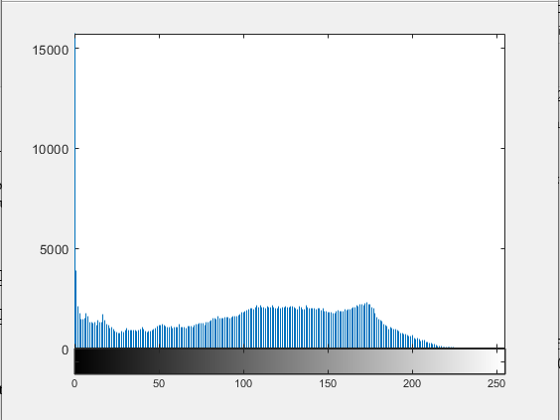Histogram: PDF:

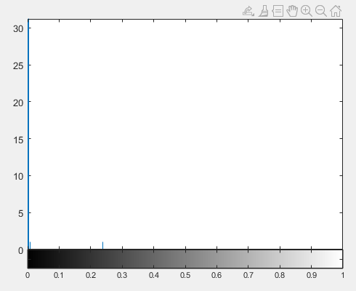

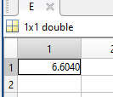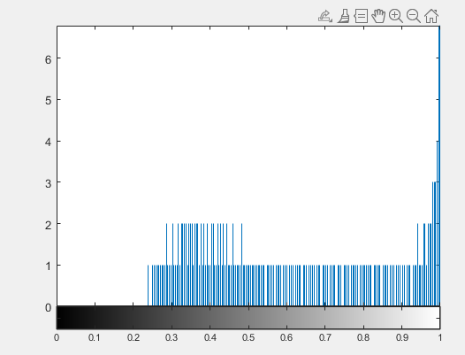CDF: Entropy:

Croppped Image: Historgam Equalization:

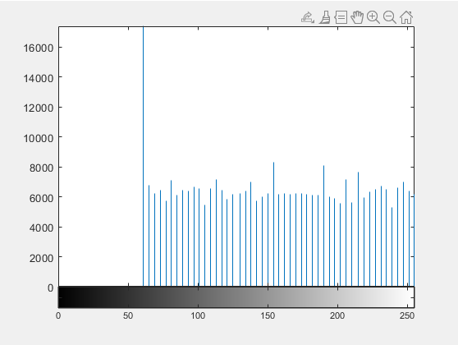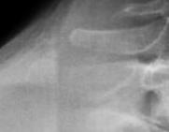

* In the lab, demonstrate the execution of the commands from #5 to #8.
* Compare the image histograms of the ROI before and after histogram equalization. Explain how the imaging quality changes.

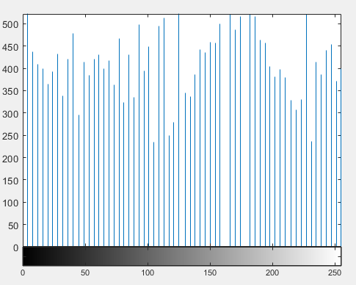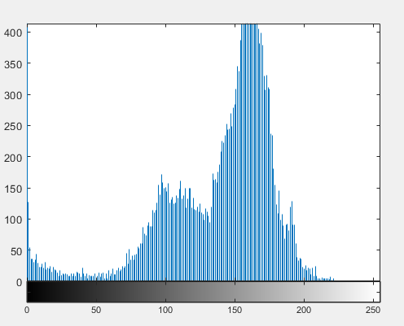Before: After: